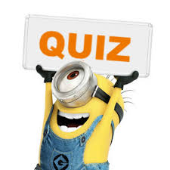 | Year 12 Methods  Term 5 Week 7 Quiz | $$\frac{}{17}$$

Name: ____Answers______________
1. | Malcolm devises the following game. He will toss two dice, and if a ‘double’ is observed he will pay his friend $3.60, otherwise his friend must pay him 60 cents. How much will Malcolm expect to win or lose per game in the long run using this strategy?  P -3.6 0.6  Pr(X=x) $$\frac{1}{6}$$ $$\frac{5}{6}$$  E(X) = ($\frac{1}{6}$ x -3.6) + ($\frac{5}{6}$ x 0.6)  = -0.1  Expected loss of 10 cents per game. | 3
2. | Suppose that X is the number of times a shooter hits a target in a competition. If the distribution of X is binomial, with probability of success of 0.67, calculate the probability that a shooter who takes five shots will hit the target three times.  Pr(X=3) = $\begin{matrix}5 \\ C \\ 3\end{matrix}$(0.67$)^{3}$(0.33$)^{2}$  = 0.3275 | 2
3. | A multiple choice test has 10 questions, each of whci has five possible answers. Find the probabillity that a student who guesses the answer to each question will have:  - No correct answers  $(\frac{4}{5})^{10}$ = 0.1074  - 5 or more correct answers  Classpad 0.0328  - At least 7 correct answers given that they have at least 5 correct answers.  Classpad 0.0262 P$\left(X≥7 | X≥5\right)$ | 4
4. |  | 7

